**1**) Title - instead of Extra Mural Lectures, IIT Hyderabad use Extramural Lectures (EML), IIT Hyderabad

**2**) About Us - Use the about us shared in this link and remove the circle/keep our logo in that circle.

<https://docs.google.com/document/d/1_GExsFQ01mRjRc3ursLszF3XRarFtsHHba2CnRP9cTM/edit>

**3)** Title for third section is – Lecture Updates.

Remove the description and in each tile use lecture title; date and location;

Since there are two tiles, update the first two tiles one with current talk and one with previous talk. I am attaching images also for your reference.

Browse all button should go to talk’s page.

**GV Ramanjaneyulu, Agricultural Scientist details:**

Title: Food, Farmers and Environment

Date: March 06th, 05.30 PM – 07.00 PM

Venue: Auditorium, A-Block

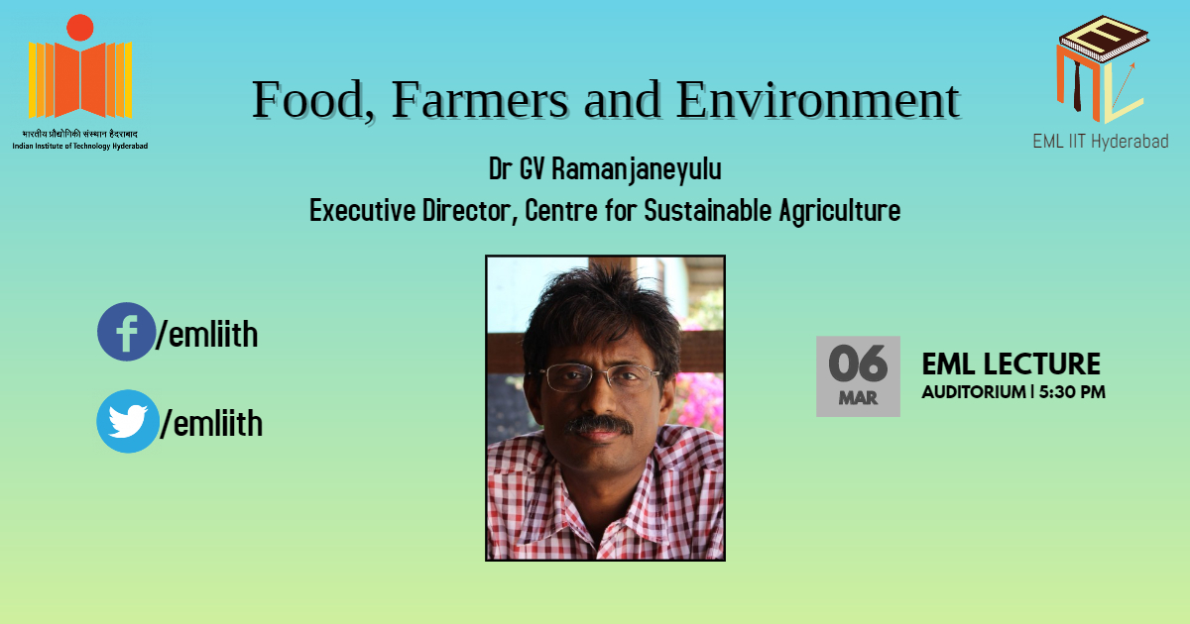

**KK Senthil Kumar, Cinematographer details:**

Title: Envision Creativity

Date: November 04th, 05.30 PM – 07.00 PM

Venue: Room No: 8, A-Block

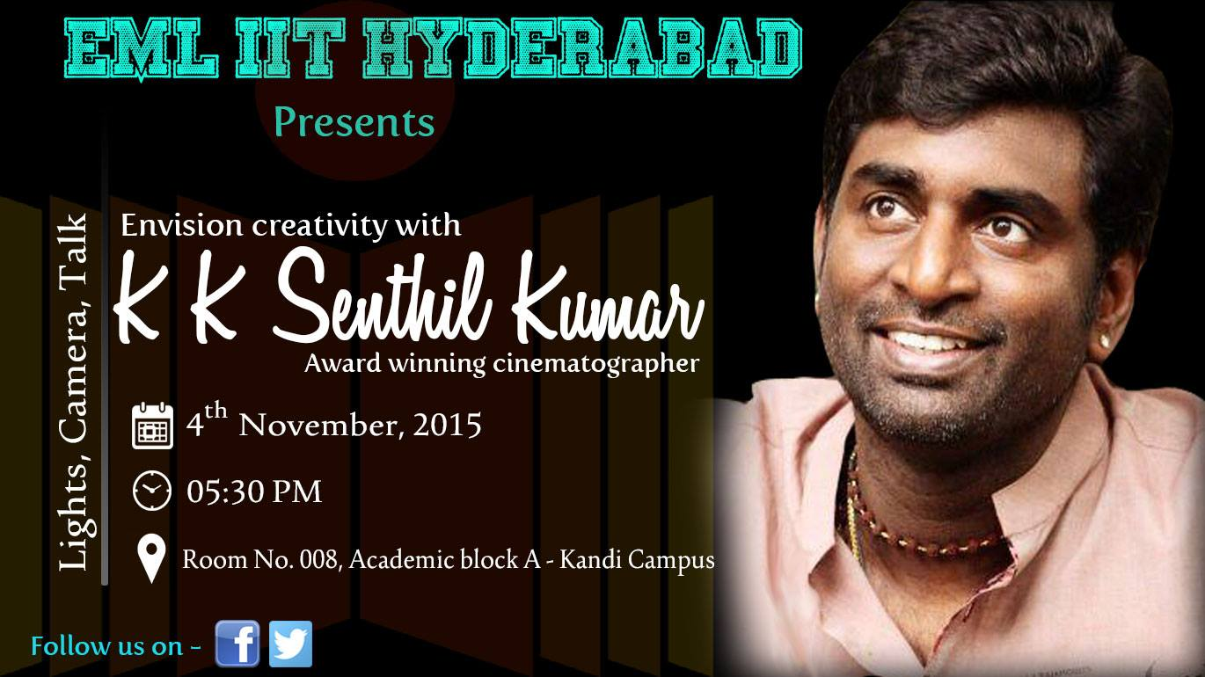

**Mr Sumit Kumar Gandhi, IAS details:**

Title: UPSC and Leadership

Date: March 16th, 05.00 PM – 06.30 PM

Venue: Room No: 119, A-Block

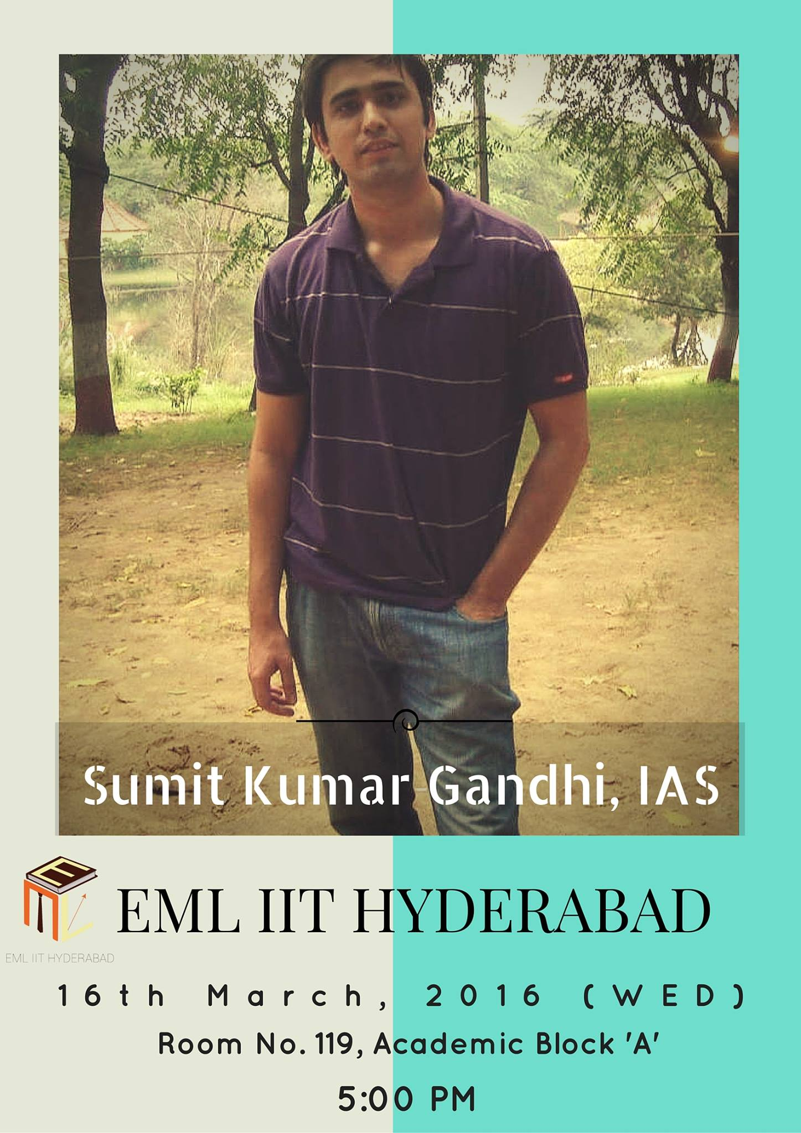

**4)** Update contact us information – No changes in description

Check if the form is sending email (at least hyperlinked) to eml@iith.ac.in

**Facebook/messenger:** [**https://www.facebook.com/emliith/**](https://www.facebook.com/emliith/)

**Twitter:** [**https://twitter.com/emliith**](https://twitter.com/emliith)

**Email:** [**eml@iith.ac.in**](mailto:eml@iith.ac.in)

**Phone Number: You can give mine :P +91-7875746216**

5) Talks page:

- change the diamond to our logo.

-change the title also from Welcome to EML IIT Hyderabad to Our speakers

-keep the photo of previous speakers and description what we have.

6) Remove Blog page

7) Add team page.

U can align the team like this

Ug rep1 ugrep2

And 7 of us below in any fashion preferably looking symmetrical.

8) Gallery page, hide it temporarily, we will update it later.